**Task 1**

1.

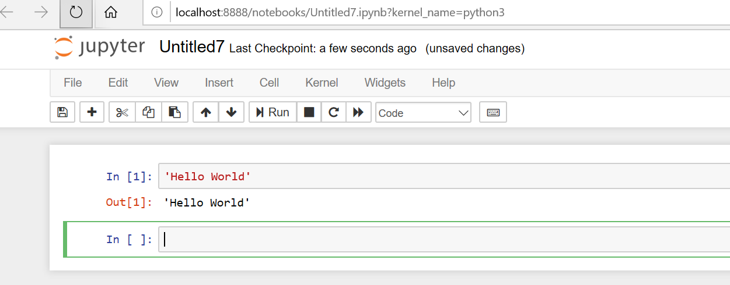

2.

l=list(range(2000,3200))

l

l.append(3200)

m=[]

for i in range(len(l)):

if (i%7 == 0 and i%5 !=0):

m.append(l[i])

m

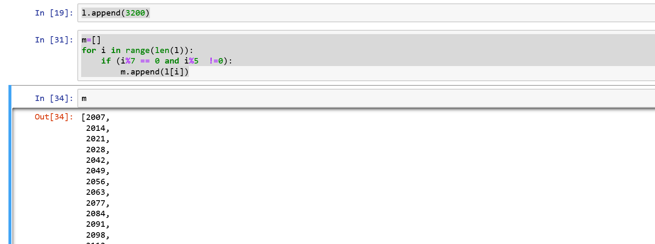

3.

a=input('Enter First Name')

a

LName=input('Enter Last Name')

LName

FullName= LName + ' ' + a

FullName

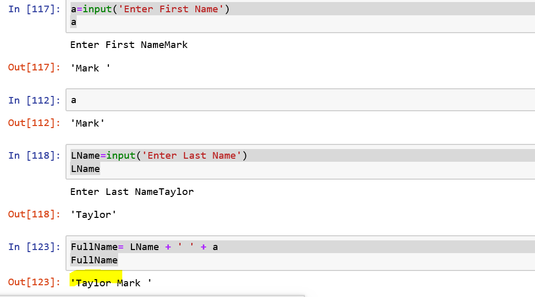

4.

diameter=12

radius=diameter/2

pi = 3.1415926535897931

print ('Volume of sphere:',4.0/3.0*pi* radius**3)

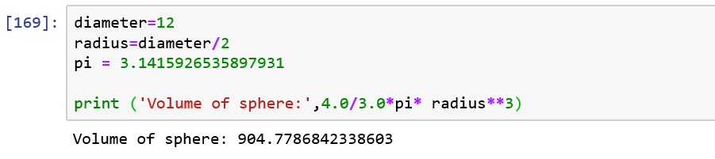

Task 2:

1

v = input("Input csv nos : ")

list = v.split(",")

print('list: ',list)

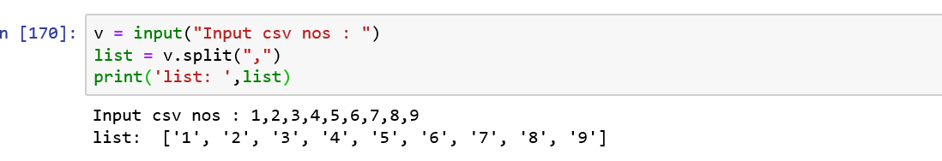

2

b=int(input('Enter no of rows '))

for i in range(0,b):

for j in range(0,i+1):

print('*', end=' ')

print("\r")

for i in range(b, 0, -1):

for j in range(0, i - 1):

print("*", end=' ')

print("\r")

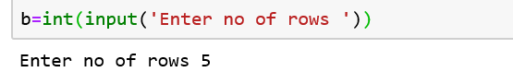

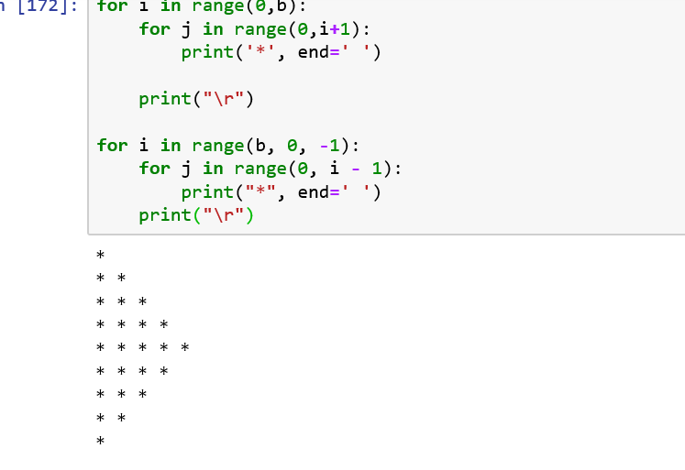

3

w=input('Enter word ')

w

w[::-1]

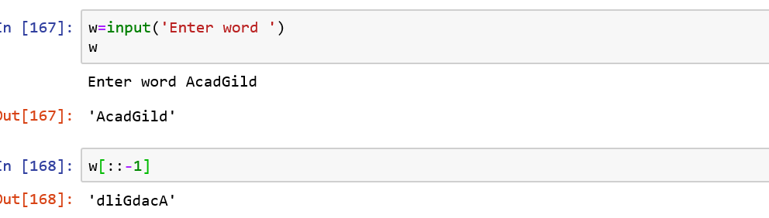

4

print('WE, THE PEOPLE OF INDIA,\n having solemnly resolved to constitute India into a SOVEREIGN, !')

print(' SOCIALIST, SECULAR, DEMOCRATIC REPUBLIC')

print(' and to secure to all its citizens')

